Why Should I Join TCATA?

Advocacy – Represents members’ interests on key legislation and regulation. Advocacy is at the heart of the Association’s mission.

The TCATA Tidings Newsletter – Informs members of Association and industry
developments as well as important legislative and regulatory issues.
Annual Management & Educational Conference – Offers both an outstanding business program and invaluable networking opportunities with colleagues from around the country.

The Clean Show – Significantly reduced exhibit rates and representation of members’ interests in setting Clean Show policy.

Protecting Member Interests on Codes– Through its work with standard-setting organizations such as the American National Standards Institute, National Fire Protection Association, and the International Code Council, TCATA ensures that members’ interests are protected.

University of Innovative Distribution – 50% discount on the registration fee for the highly acclaimed educational program.

- Service First Processing – Service First Processing (SFP) and TCATA have put together a special member only program with benefits that are designed to reduce your cost of credit card processing while improving your level of service and support.

- Webinars– On issues such as health care, sales, economic forecasting and exporting.

College Scholarship Fund – For employees or the children of employees.

Advice from top consultants on EPA, OSHA and human resources/legal issues.

… and much more! It would be hard to find a better investment of your money.
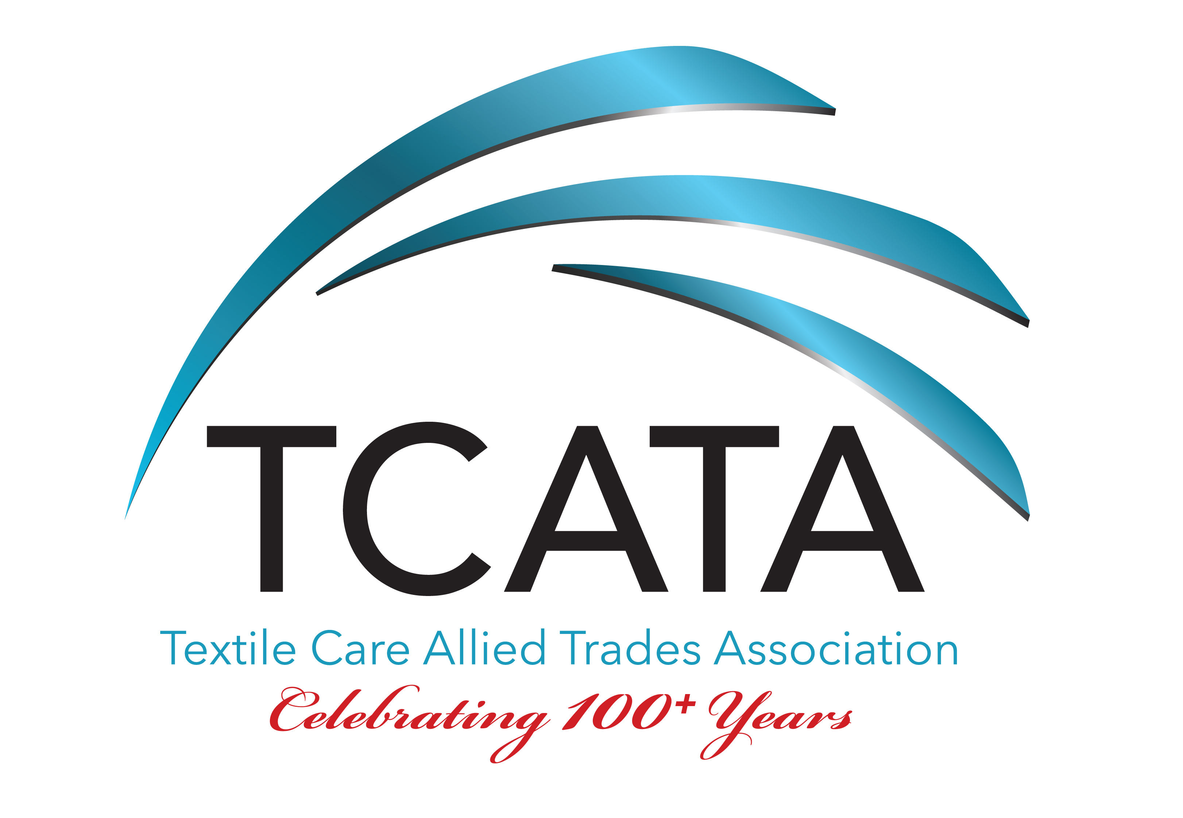
TCATA Application for Membership
Textile Care Allied Trades Association, Inc.
P: (813) 348-0075
E-mail: luci@tcata.org – Web site: www.tcata.org

Qualifications for Membership:

Membership in the Association is available to companies of good repute in one or more of the following business categories serving the textile care industry:

•North American manufacturers or distributors of supplies or machinery/equipment.
•Consultants/Installers - includes facility planning/design, construction, installation and project management.
•International manufacturers or distributors with no offices in North America.
•Related Trades – companies otherwise eligible for membership, i.e. textiles, control systems,
computer software, trade magazines, etc.
Company Name:
Address:
Phone: Fax: Cell:
Website: Year Company Established:
Name of person with voting authority:
Email:
Signature:
Title: Date:
Print Name:
Billing Contact: Email:

Please describe your products, service(s), type of equipment and companies you represent:

Classification of Company (check one):
North American  Machinery or Supply Manufacturer
 Distributor
 Related Trades
 International Company (no offices in North America)

2024 Dues:
Manufacturers $845
Distributors/Related Trades/International $595

Payment method: Check (payable to TCATA)  Credit Card (Amex/Visa/Mastercard/Discover)
Cardholder Name:
Address
Card Number: Exp. Date CVV

